

[ SW2 ]

Online Clothes Shopping Website

Project ID :22

Team ID :46





##### **Description**

##### The shop Management system otherwise referred to as the shop information system stores data about their customers , orders and items.

##### **Business Benefits**

Information technology is growing day-by-day. The system developer makes use of this golden opportunity to help the shop in controlling their stock , adding their new fashioned clothes, applying online shopping, and to follow the items sales to improve their revenue.

# Functional requirements

o The system shall reflect a new and changed product description within x minutes of the database being updated by the product owner. This will reduce the number of incidents of incorrectly displayed information by x%. This eliminates the current redundant update of information, saving $y dollars annually.

o The system shall provide accounting with accurate purchase transaction data. This will improve customer service by reducing billing complaints by x% and save $y in correcting inaccurate accounts.

o The system shall provide customer information for the sells agent.

o The system shall allow the ease of shopping and sells items online

o The system shall show the customer the total cost before placing the order, this will reduce returning orders, because the customer will be fully aware of what he will be paying.

o The system shall provide product categories.

* + **Non-Functional requirements**

## Usability

A user should know how to use the website from the first time.

A user who already knows what product he is interested in should be able to locate and view that page in x seconds.

The final payment transaction shall be done in one click.

* **Security**

The system shall provide login form with a password.

Transaction data must be transmitted in encrypted form.

## Interfaces

* **The system must interface with**

The current MySQL systems for product ,customer and

order information.

### System capabilities

### **.**Login Module

* In order, to get personalized or restricted information, place orders or do other specialized transactions a user must login so that the system can determine his access level.

## User Level Features

* + A user must have an account to complete the order process.
  + if the user does not have an account he needs to sign-up.
  + Sign-up Form

**User enters a valid user name.**

**User enters a password.**

**User confirm the password.**

**User enters first name.**

**User enters last name.**

**User enters Address.**

**User enters a valid phone number .**

* If registration was successful, user’s data will be stored into the database and a registration succeed message will appear to the user.
* If the user already has an account, he must log in.

o Log in form

* **User must enter an username that is already stored in the database.**
* **User enters a password that is already stored in the database with the same email.**
* If logging in was successful, user will be able to use all the user’s
* features.
* **User Look for a product and add it to the cart.**

User firstly choose the category either is men or women.

Then he add the product he liked to the shopping cart

* If user have found the product he was looking for, he can place his order successfully.

o Placing Order Form

* **User can add to cart by clicking “+”**
* **User can add products of different quantities in the same order.**
* **Then he can open cart page and confirm his order.**
* If the user added to his cart successfully, he will be able to go to the next stage, to check out.

## payment information and order confirmation

* + Order confirmation Form
* **User can view it’s cart.**
* **User can view it’s cart, by clicking the cart mark.**
* **User can delete from the he’s cart, by clicking the deletion mark.**
* If the user has updated his order successfully, he will go to the info/delivery page.
  + Payment Information Form
    - Form
* **User must enter a valid Credit card number, equal to 16 digits.**
* **User must enter the card’s name must be in English letter.**
* **User must enter the CVV number, not more than 3 digits.**

**If the CVV number was invalid the system will display an error.**

* **User must click on “pay” in order for the process to be completed.**
* **Each order must decrease the product quantity in the inventory.**

## Admin Level Features

* **Admin can view the users details, their information.**
* **Admin can view the orders placed by the customers, their bills.**
* **Admin can add , edit or delete items to database**

## Use-Case Diagram

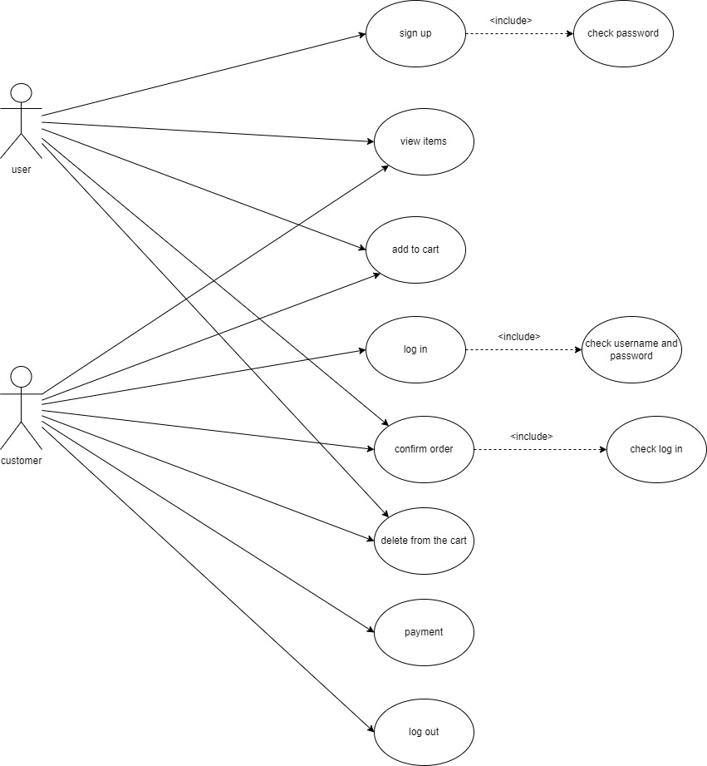

## Activity Diagram(s)

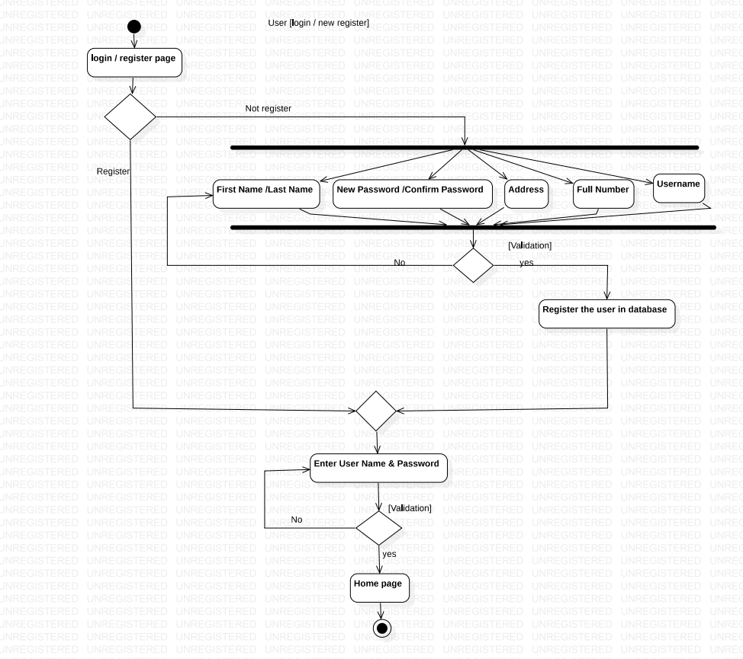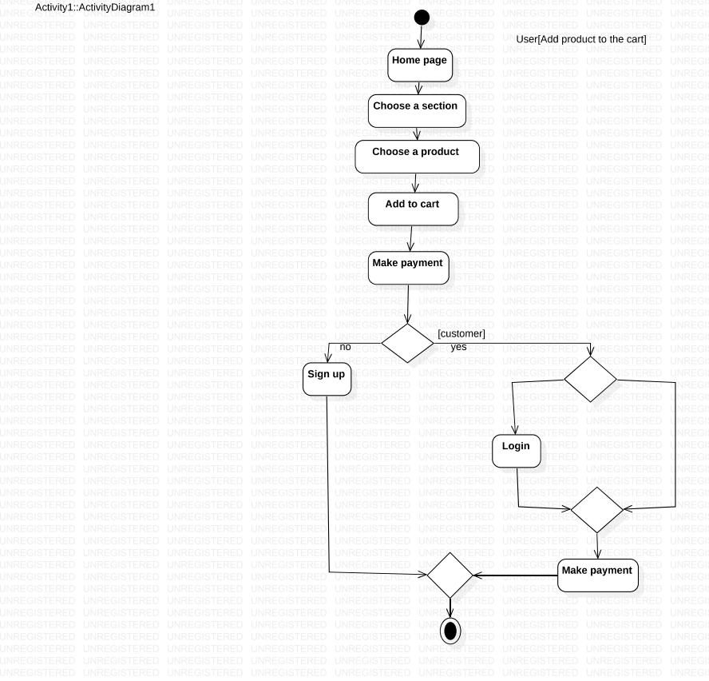

# System Architecture

## Sequence Diagram(s)

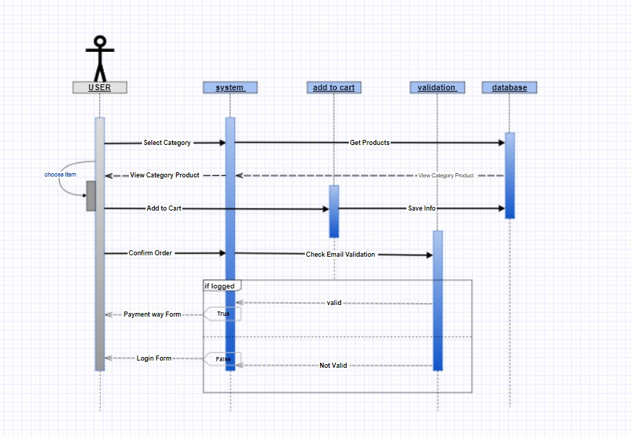

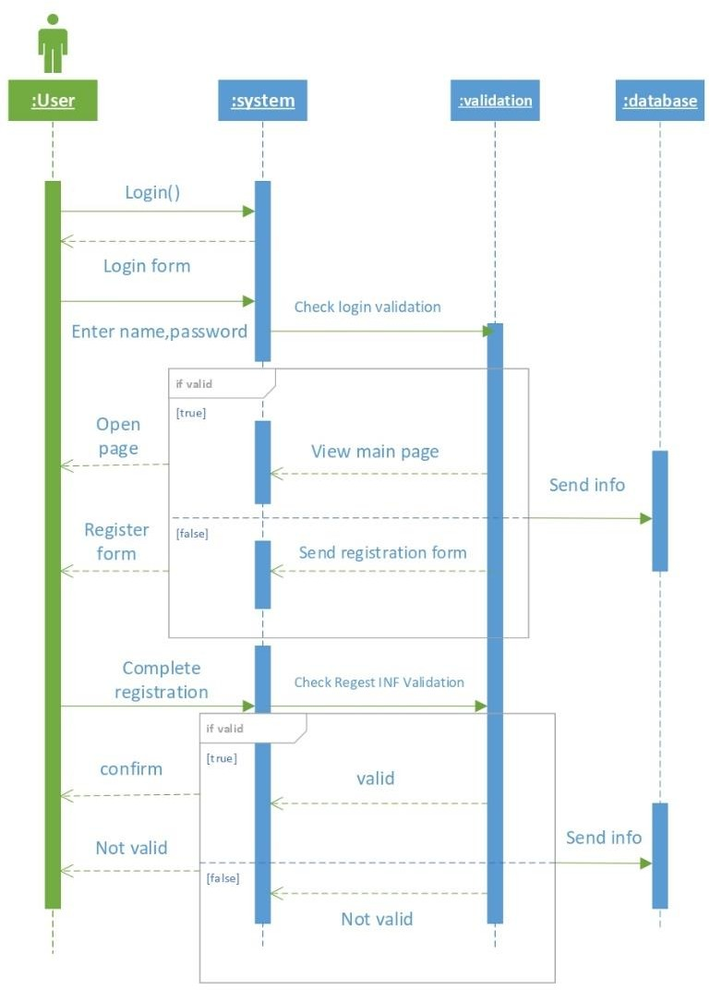

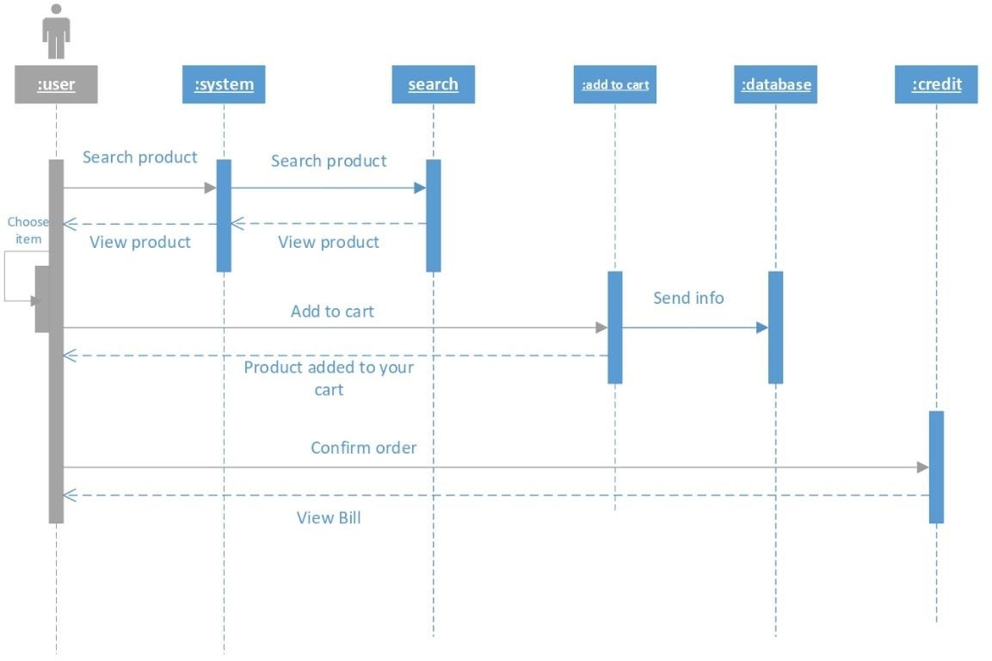

* **class Diagram:**

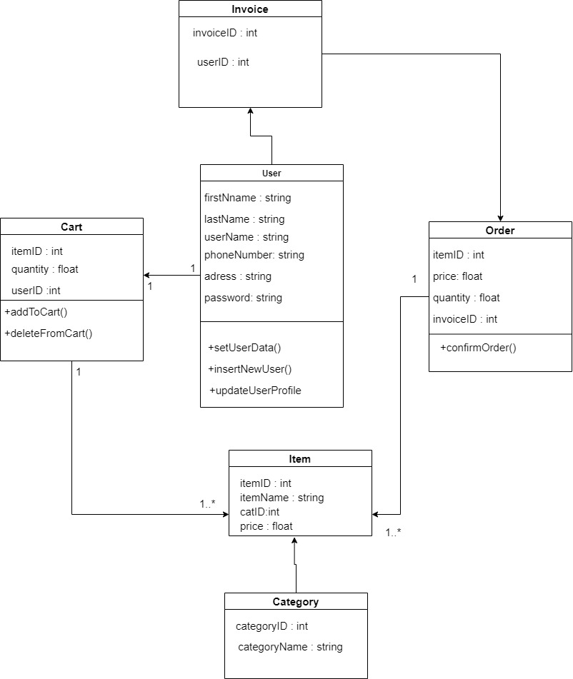

* **Database Schema**

